1. go to https://www.poste.it/index.html
2. select Paga Online
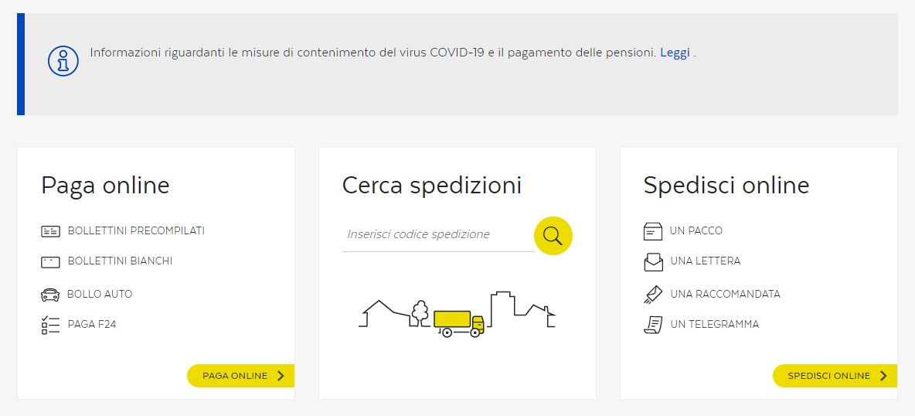
3. select Bolletino Bianco > Paga
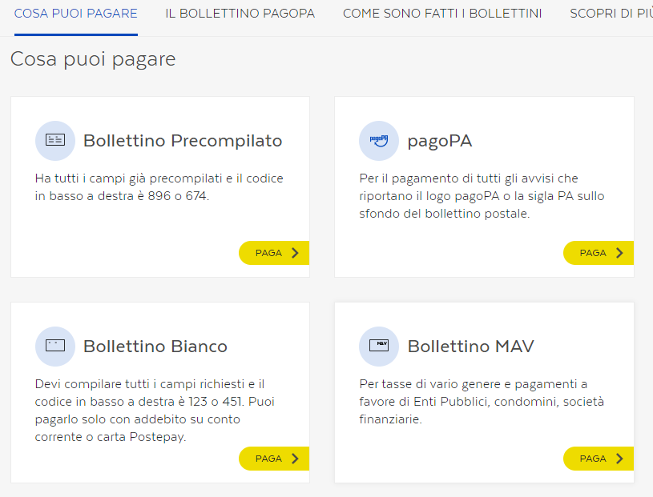
4. you will be prompted to login to your account

5. select Bolletini > Paga
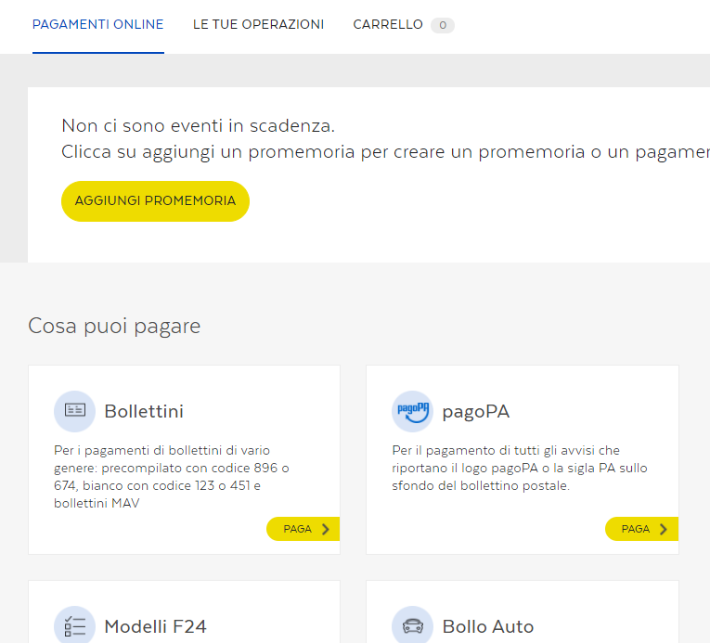

6. Select Bolletino Bianco tab and then Continua
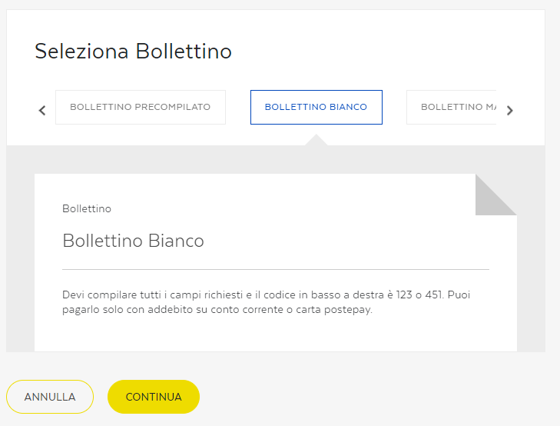

7. Fill up the Form
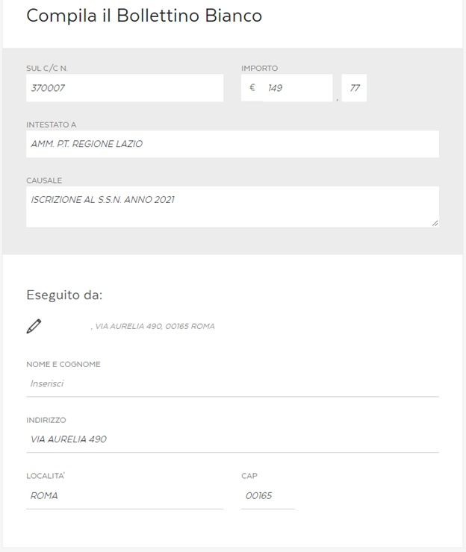

8. Proceed to Payment with Postepay

